***Virginia Junior Classical League***

*presents this*

Certificate of Excellence

*to*

Emily Cannon

*of*

Patrick Henry High School

*for*

*5th Place in Greeting Card*

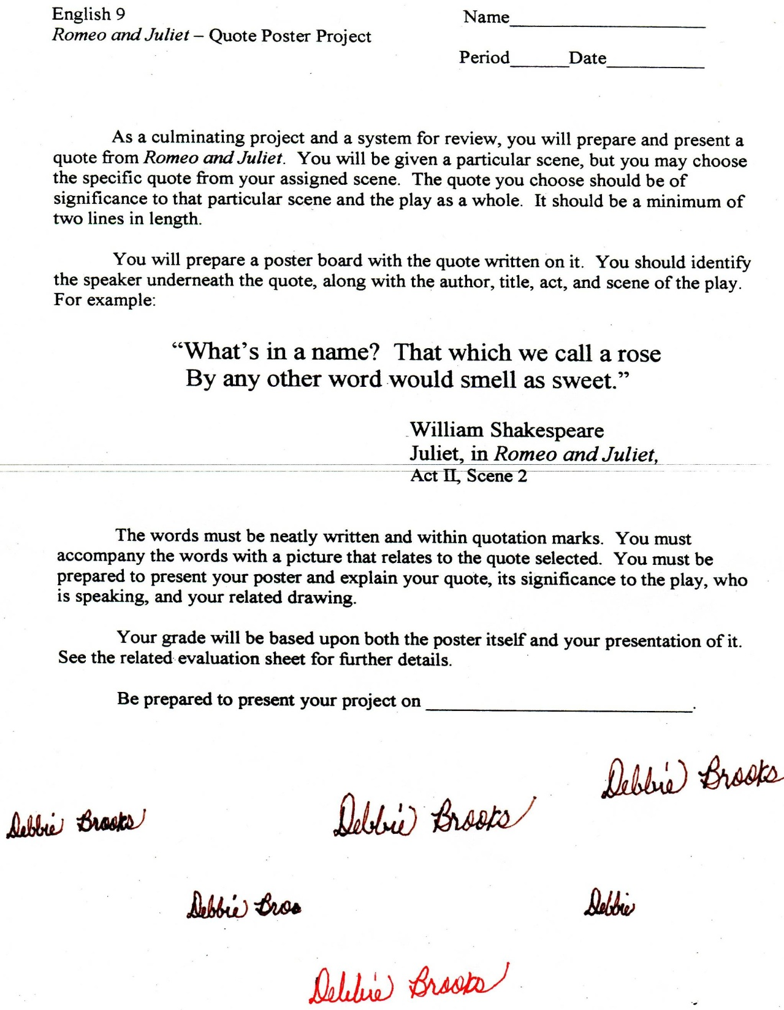

Microsoft Office Signature Line...

*a.d. viii Kal. Dec. MMDCCLXVII A.U.C. 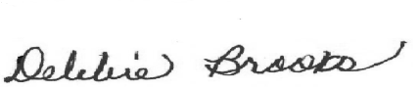*

***Virginia Junior Classical League***

*presents this*

Certificate of Excellence

*to*

Mary Gier

*of*

Patrick Henry High School

*for*

*9th Place in Vocabulary*

**

Microsoft Office Signature Line...

*a.d. viii Kal. Dec. MMDCCLXVII A.U.C. *